

SCE Training Curriculum

Siemens Automation Cooperates with Education | 05/2017

Beschreibung: SIE_Logo_Layer_Petrol_RGB_A4_56mmTIA Portal Module 032-500

Analog Values  
for SIMATIC S7-1500

**Matching SCE trainer packages for these training curriculums**

SIMATIC Controllers

* **SIMATIC ET 200SP Open Controller CPU 1515SP PC F and HMI RT SW**Order no.: 6ES7677-2FA41-4AB1
* **SIMATIC ET 200SP Distributed Controller CPU 1512SP F-1 PN Safety**

Order no.: 6ES7512-1SK00-4AB2

* **SIMATIC CPU 1516F PN/DP Safety**

Order no.: 6ES7516-3FN00-4AB2

* **SIMATIC S7 CPU 1516-3 PN/DP**Order no.: 6ES7516-3AN00-4AB3
* **SIMATIC CPU 1512C PN with Software and PM 1507**Order no.: 6ES7512-1CK00-4AB1
* **SIMATIC CPU 1512C PN with Software, PM 1507 and CP 1542-5 (PROFIBUS)**Order no.: 6ES7512-1CK00-4AB2
* **SIMATIC CPU 1512C PN with Software**Order no.: 6ES7512-1CK00-4AB6
* **SIMATIC CPU 1512C PN with Software and CP 1542-5 (PROFIBUS)**Order no.: 6ES7512-1CK00-4AB7

**SIMATIC STEP 7 Software for Training**

* **SIMATIC STEP 7 Professional V14 SP1 - Single license**Order no.: 6ES7822-1AA04-4YA5
* **SIMATIC STEP 7 Professional V14 SP1- Classroom license (up to 6 users)**Order no.: 6ES7822-1BA04-4YA5
* **SIMATIC STEP 7 Professional V14 SP1 - Upgrade license (up to 6 users)**Order no.: 6ES7822-1AA04-4YE5
* **SIMATIC STEP 7 Professional V14 SP1 - Student license (up to 20 users)**Order no.: 6ES7822-1AC04-4YA5

Please note that these trainer packages are replaced with successor packages when necessary.

An overview of the currently available SCE packages is provided at: [siemens.com/sce/tp](http://www.siemens.com/sce/tp)

**Continued training**

For regional Siemens SCE continued training, please contact your regional SCE contact [siemens.com/sce/contact](http://www.siemens.com/contact)

**Additional information regarding SCE**

[siemens.com/sce](http://www.siemens.com/sce)

**Information regarding use**

The SCE training curriculum for the integrated automation solution Totally Integrated Automation (TIA) was prepared for the program "Siemens Automation Cooperates with Education (SCE)" specifically for training purposes for public educational and R&D institutions. Siemens AG does not guarantee the contents.

This document is to be used only for initial training on Siemens products/systems. This means it can be copied in whole or part and given to those being trained for use within the scope of their training. Circulation or copying this training curriculum and sharing its content is permitted within public training and advanced training facilities for training purposes.

Exceptions require written consent from the Siemens AG contact: Roland Scheuerer roland.scheuerer@siemens.com.

Offenders will be held liable. All rights including translation are reserved, particularly if a patent is granted or a utility model or design is registered.

Use for industrial customer courses is expressly prohibited. We do not consent to commercial use of the training curriculums.

We wish to thank the TU Dresden, especially Prof. Dr.-Ing. Leon Urbas, the Michael Dziallas Engineering Corporation and all other involved persons for their support during the preparation of this training curriculum.

Table of contents

[1 Goal 5](#_Toc486000036)

[2 Prerequisite 5](#_Toc486000037)

[3 Required hardware and software 6](#_Toc486000038)

[4 Theory 7](#_Toc486000039)

[4.1 Analog signals 7](#_Toc486000040)

[4.2 Measuring transducers 8](#_Toc486000041)

[4.3 Analog modules – A/D converter 8](#_Toc486000042)

[4.4 Data types of the SIMATIC S7-1500 9](#_Toc486000043)

[4.5 Reading/outputting analog values 10](#_Toc486000044)

[4.6 Normalizing analog values 11](#_Toc486000045)

[5 Task 12](#_Toc486000046)

[6 Planning 12](#_Toc486000047)

[6.1 Analog control of the conveyor speed 12](#_Toc486000048)

[6.2 Technology diagram 13](#_Toc486000049)

[6.3 Reference list 14](#_Toc486000050)

[7 Structured step-by-step instructions 15](#_Toc486000051)

[7.1 Retrieve an existing project 15](#_Toc486000052)

[7.2 Create the "MOTOR\_SPEEDCONTROL" function 17](#_Toc486000053)

[7.3 Configuration of the analog output channel 24](#_Toc486000054)

[7.4 Expand the tag table to include analog signals 25](#_Toc486000055)

[7.5 Call the block in the organization block 26](#_Toc486000056)

[7.6 Save and compile the program 29](#_Toc486000057)

[7.7 Download the program 30](#_Toc486000058)

[7.8 Monitor program blocks 31](#_Toc486000059)

[7.9 Archive the project 33](#_Toc486000060)

[8 Checklist 34](#_Toc486000061)

[9 Exercise 35](#_Toc486000062)

[9.1 Task – Exercise 35](#_Toc486000063)

[9.2 Technology diagram 36](#_Toc486000064)

[9.3 Reference list 37](#_Toc486000065)

[9.4 Planning 37](#_Toc486000066)

[9.5 Checklist – Exercise 38](#_Toc486000067)

[10 Additional information 39](#_Toc486000068)

Analog Values for SIMATIC S7-1500

# Goal

In this chapter, you will become acquainted with the analog value processing of the SIMATIC S7-1500 with the TIA Portal programming tool.

The module explains the acquisition and processing of analog signals and gives a step-by-step description of read and write access to analog values in the SIMATIC S7-1500.

The SIMATIC S7 controllers listed in Chapter 3 can be used.

# Prerequisite

This chapter builds on the chapter IEC Timers and Counters with the SIMATIC S7 CPU1516F-3 PN/DP. You can use the following project for this chapter, for example: 032-300 IEC Timers and Counters.zap13

# Required hardware and software

**1** Engineering station: requirements include hardware and operating system   
(for additional information, see Readme on the TIA Portal Installation DVDs)

**2** SIMATIC STEP 7 Professional software in TIA Portal – as of V13

**3** SIMATIC S7-1500/S7-1200/S7-300 controller, e.g. CPU 1516F-3 PN/DP –   
Firmware as of V1.6 with memory card and 16DI/16DO and 2AI/1AO  
Note: The digital inputs and analog inputs and outputs should be fed out to a control panel.

**4** Ethernet connection between engineering station and controller

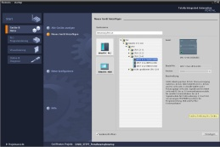

**2** SIMATIC STEP 7 Professional (TIA Portal) as of V13



**1** Engineering station

**4** Ethernet connection



Control panel

**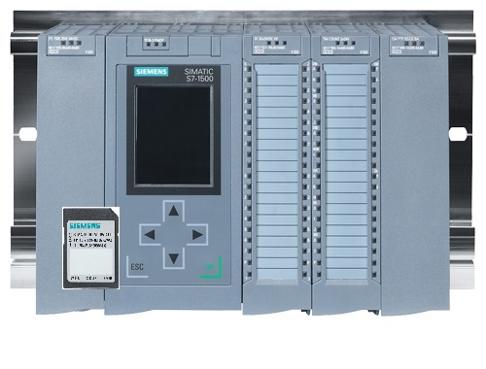**

**3** SIMATIC S7-1500 controller

# Theory

## Analog signals

In contrast to a binary signal, which can assume only two signal states (“Voltage present +24 V” and “Voltage not present 0 V”), analog signals can assume any value within a defined range. A typical example of an analog sensor is a potentiometer. Depending on the position of the knob, any resistance can be set, up to the maximum value.

Examples of analog quantities in control engineering:

- Temperature -50 to +150 °C

- Flow rate 0 to 200 l/min

- Speed -500 to +50 rpm

- etc.

## Measuring transducers

These quantities are converted to electrical voltages, currents or resistances with the help of a measuring transducer. If, for example, a speed is to be measured, the speed range of 500 to 1500 rpm can be converted to a voltage range of 0 to +10 V using a measuring transducer. At a measured speed of 865 rpm, the measuring transducer would output a voltage value of +3.65 V.

**1500 rpm**



1000 rpm

**+10 V**

**10 V: 1000 rpm = 0.01 V/rpm**

**365 rpm x 0.01 V/rpm = 3.65 V**

## Analog modules – A/D converter

These electrical voltages, currents or resistances are then connected to an analog module that digitizes this signal for further processing in the PLC.

If analog quantities will be processed with a PLC, the read-in voltage, current or resistance value must be converted to digital information. The analog value is converted to a bit pattern. This conversion is referred to as analog-to-digital conversion (A/D conversion). This means, for example, that the voltage value of 3.65 V is stored as information in a series of binary digits.

The result of this conversion is always a 16-bit word for SIMATIC products. The integrated ADC (analog-to-digital converter) of the analog input module digitizes the analog signal being acquired and approximates its value in the form of a stepped curve. The most important parameters of an ADC are its resolution and conversion rate.

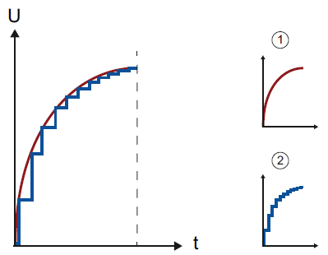

1: Analog value

2. Digital value

The more binary digits the digital representation uses, the finer the resolution is. For example, if only 1 bit was available for the voltage range of 0 to +10 V, you would only know whether the measured voltage is between 0 and +5 V or between +5 V and +10 V. With 2 bits, the range can be divided into 4 individual ranges, i.e., 0 to 2.5 / 2.5 to 5 / 5 to 7.5 / 7.5 to 10 V. Conventional A/D converters in control engineering use 8 or 11 bits for converting.

With 8 bits you have 256 individual ranges, while 11 bits provide a resolution of 2048 individual ranges.

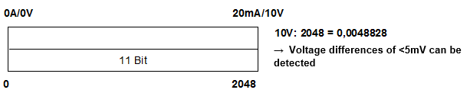

11-bit

**2048**

**0A/0V**

**20mA/10V**

**10 V: 2048 = 0.0048828**

🡪 **Voltage differences of <5 mV can be detected**

## Data types of the SIMATIC S7-1500

The SIMATIC S7-1500 has many different data types for representing different numerical formats. A list of some of the elementary data types is given below.

|  |  |  |  |
| --- | --- | --- | --- |
| **Data type** | **Size (bits)** | **Range** | **Example of constant entry** |
| Bool | 1 | 0 to 1 | TRUE, FALSE, O, 1 |
| Byte | 8 | 16#00 to 16#FF | 16#12, 16#AB |
| Word | 16 | 16#0000 to 16#FFFF | 16#ABCD, 16#0001 |
| DWord | 32 | 16#00000000 to 16#FFFFFFFF | 16#02468ACE |
| Char | 8 | 16#00 to 16#FF | 'A', ‘r’, ‘@’ |
| Sint | 8 | -128 to 127 | 123,-123 |
| **Int** | **16** | **-32,768 to 32,767** | **123, -123** |
| Dint | 32 | -2,147,483,648 to 2,147,483,647 | 123, -123 |
| USInt | 8 | 0 to 255 | 123 |
| Ulnt | 16 | 0 to 65,535 | 123 |
| UDInt | 32 | 0 to 4,294,967,295 | 123 |
| **Real** | **32** | **+/-1.18 x 10 -38 to +/-3.40 x 10 38** | **123.456, -3.4, -1.2E+12, 3.4E-3** |
| LReal | 64 | +/-2.23 x 10 -308 to +/-1.79 x 10 308 | 12345.123456789  -1.2E+40 |
| Time | 32 | T#-24d\_20h\_31 m\_23s\_648ms to T#24d\_20h\_31 m\_23s\_647ms  Saved as: -2,147,483,648 ms to +2,147,483,647 ms | T#5m\_30s  5#-2d  T#1d\_2h\_15m\_30x\_45ms |
| String | Variable | 0 to 254 characters in byte size | 'ABC' |

**Note:** The **'INT'** and **'REAL'** data types play a large role in analog value processing. This is because read-in analog values exist as 16-bit integers in the '**INT'** format, and in order to ensure exact further processing only **'REAL'** floating-point numbers should be used due to rounding errors in the case of '**INT'**.

## Reading/outputting analog values

Analog values are read into the PLC or output from the PLC as word information. These words are accessed, for example, with the following operands:

%IW 64 Analog input word 64

%QW 64 Analog output word 64

Each analog value (“channel”) occupies one input or output word. The format is **‘Int’**, an integer.

The addressing of input and output words conforms to the addressing in the device overview. For example:

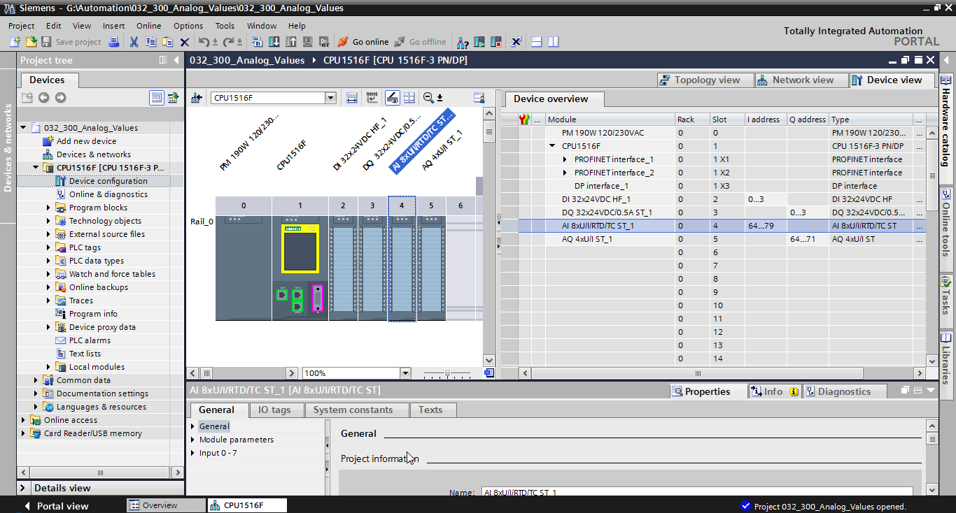

Here, the address of the first analog input would be %IW 64, that of the second analog input %IW 66, that of the third analog input %IW68, that of the fourth analog input %IW70, that of the fifth analog input %IW72, that of the sixth analog input %IW74, that of the seventh analog input %IW 76 and that of the eighth analog input %IW78.

The address of the first analog output would be %QW64, that of the second analog output %QW66, that of the third analog output %QW 68 and that of the fourth analog output %QW70.

The analog value transformation for further processing in the PLC is the same for analog inputs and analog outputs.

The digitized value ranges are as follows:

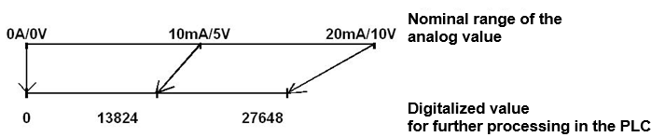

**10 mA/5 V**

**13824**

**27648**

**Digitalized value for further processing in the PLC**

**20mA/10V**

**Nominal range of the analog value**

**0A/0V**

Often, these digitized values still have to be normalized by further processing them in the PLC in an appropriate manner.

## Normalizing analog values

If an analog input value exists as a digitized value in the range +/- 27648, it must usually still be normalized so that the numerical values correspond to the physical quantities in the process.

Likewise, the analog output usually results from setting of a normalized value that then still has to be scaled to the output value +/- 27648.

In the TIA Portal, ready-made blocks or arithmetic operations are used for normalizing and scaling.

For this to be carried out as exactly as possible, the values for the normalizing must be converted to the REAL data type to minimize rounding errors.

# Task

In this chapter, a function for analog control of the conveyor speed will be added to the program from chapter "SCE\_EN\_032-300 IEC Timers and Counters".

# Planning

The analog control of the conveyor speed will be programmed in the "MOTOR\_SPEEDCONTROL" [FC10] function as an expansion of the "SCE\_EN\_032-300 IEC Timers and Counters" project. This project must be retrieved from the archive in order to add this function. The "MOTOR\_ SPEEDCONTROL" [FC10] function will be called in the "Main“ [OB1]" organization block and wired. The control of the conveyor motor must be changed to ‑ Q3 (conveyor motor -M1 variable speed).

## Analog control of the conveyor speed

The speed will be set at an input of the "MOTOR\_SPEEDCONTROL" [FC10] function in revolutions per minute (range: +/- 50 rpm). The data type is 32-bit floating-point number (Real).

First, the function will be checked for correct entry of the speed setpoint in the range +/- 50 rpm.

If the speed setpoint is outside the range +/- 50 rpm, the value 0 with data type 16-bit integer (Int) will be output at the output. The return value of the function (Ret\_Val) will then be assigned the value TRUE (1).

If the speed setting is within the range +/- 50 rpm, this value will first be normalized to the range 0…1 and then scaled to +/- 27648 with data type 16-bit integer (Int) for output as the speed manipulated value at the analog output.

The output will then be connected with signal U1 (manipulated value speed of the motor in 2 directions +/- 10V corresponds to +/- 50 rpm).

## Technology diagram

Here you see the technology diagram for the task.

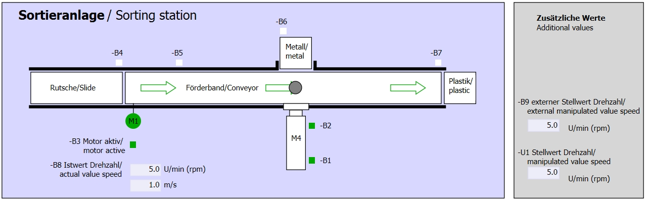

Figure 1: Technology diagram

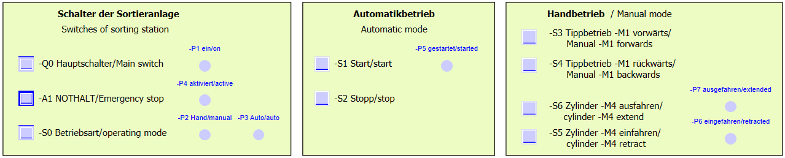

Figure 2: Control panel

## Reference list

The following signals are required as global operands for this task.

|  |  |  |  |  |
| --- | --- | --- | --- | --- |
| **DI** | **Type** | **Identifier** | **Function** | **NC/NO** |
| I 0.0 | BOOL | -A1 | Return signal emergency stop OK | NC |
| I 0.1 | BOOL | -K0 | Main switch "ON" | NO |
| I 0.2 | BOOL | -S0 | Mode selector manual (0)/ automatic (1) | Manual = 0  Auto = 1 |
| I 0.3 | BOOL | -S1 | Pushbutton automatic start | NO |
| I 0.4 | BOOL | -S2 | Pushbutton automatic stop | NC |
| I 0.5 | BOOL | -B1 | Sensor cylinder -M4 retracted | NO |
| I 1.0 | BOOL | -B4 | Sensor part at slide | NO |
| I 1.3 | BOOL | -B7 | Sensor part at end of conveyor | NO |

|  |  |  |  |  |
| --- | --- | --- | --- | --- |
| **DO** | **Type** | **Identifier** | **Function** |  |
| Q 0.2 | BOOL | -Q3 | Conveyor motor -M1 variable speed |  |
| QW 64 | BOOL | -U1 | Manipulated value speed of the motor in 2 directions +/- 10V corresponds to +/- 50 rpm |  |

***Legend for reference list***

|  |  |
| --- | --- |
| DO | Digital Output |
| AO | Analog Output |
| Q | Output |

|  |  |
| --- | --- |
| DI | Digital Input |
| AI | Analog Input |
| I | Input |
| NC | Normally Closed |
| NO | Normally Open |

# Structured step-by-step instructions

You can find instructions on how to carry out planning below. If you already have a good understanding of everything, it will be sufficient to focus on the numbered steps. Otherwise, simply follow the detailed steps in the instructions.

## Retrieve an existing project

* Before we can expand the "SCE\_EN\_032-300\_IEC\_Timers\_Counters.zap13 project from chapter "SCE\_EN\_032-300\_IEC\_Timers\_Counters", we must retrieve this project from the archive. To retrieve an existing project that has been archived, you must select the relevant archive with → Project → Retrieve in the project view. Confirm your selection with Open.   
  (→ Project → Retrieve → Select a .zap archive → Open)

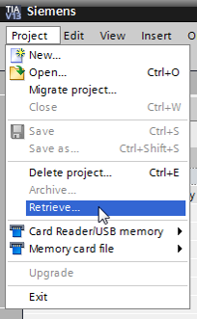

* The next step is to select the target directory where the retrieved project will be stored. Confirm your selection with "OK".   
  (→ Target directory → OK)
* Save the opened project under the name 032-500\_Analog\_Values.   
  (→ Project → Save as … → 032-500\_Analog\_Values → Save)

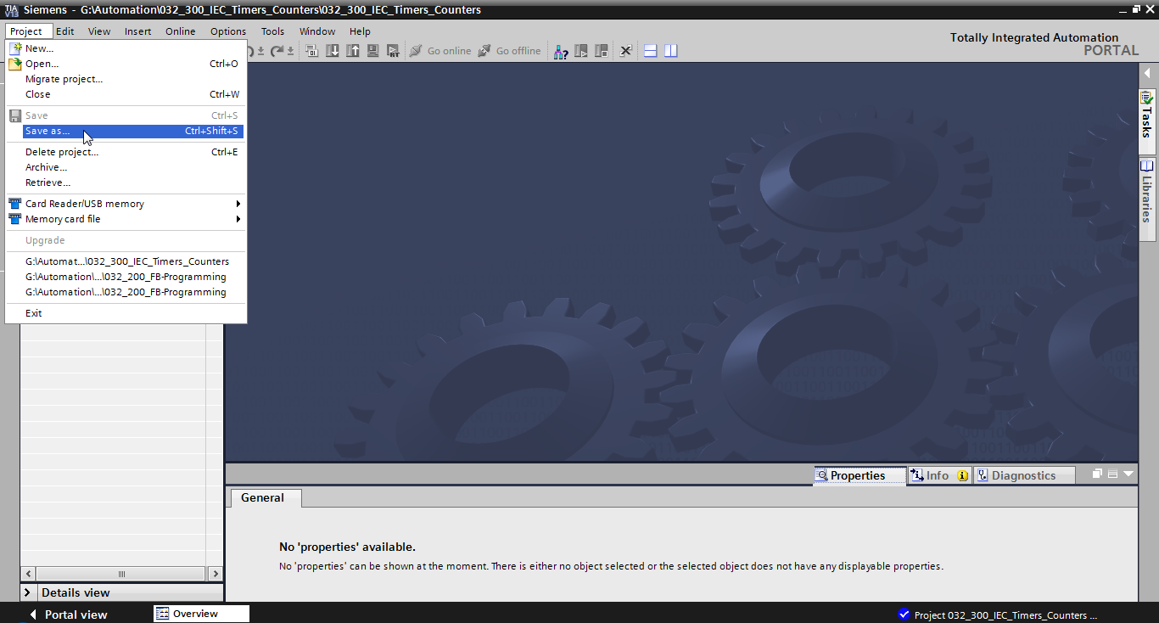

## Create the "MOTOR\_SPEEDCONTROL" function

* Select the 'Program blocks' folder of your CPU 1516F-3 PN/DP and then click "Add new block" to create a new function there.

(→ CPU\_1516F [CPU 1516F-3 PN/DP] → Add new block)

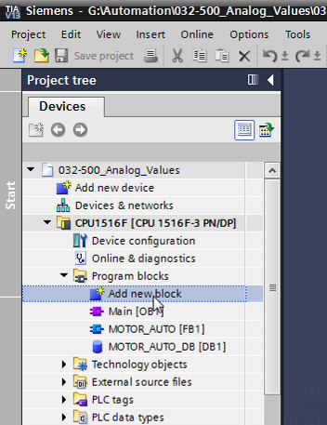

* Select  in the next dialog and rename your new block to: "MOTOR\_SPEEDCONTROL". Set the language to FBD and manually assign the number "10". Select the "Add new and open" check box. Click "OK".

(→→ Name: MOTOR\_SPEEDCONTROL → Language: FBD → Number: 10 Manual →  Add new and open → OK)

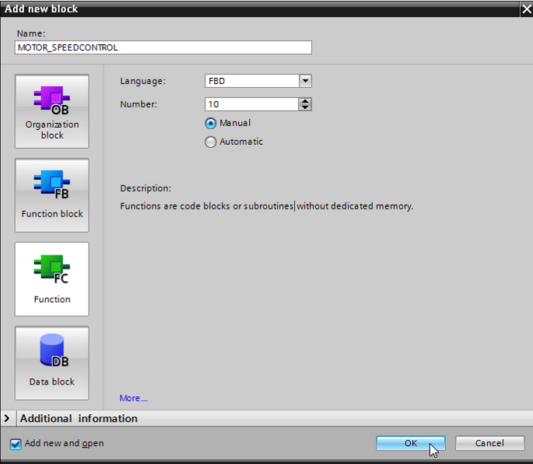

* Create the local tags with their comments as shown here and change the data type of the 'Return' tag from 'Void' to 'Bool'.   
  (→ Bool)

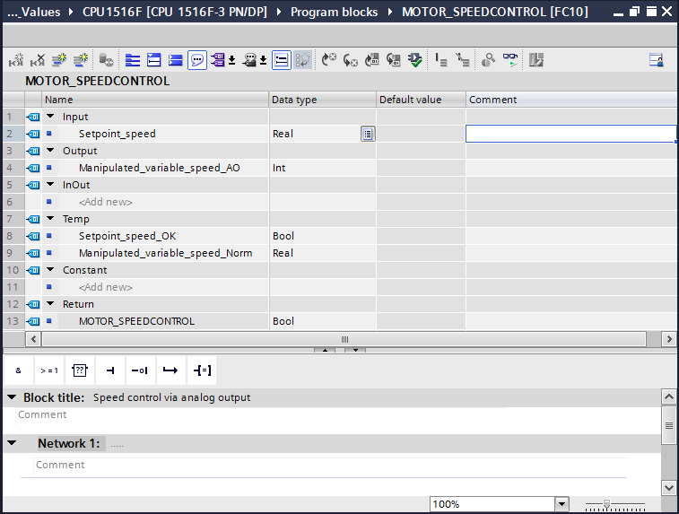

**Note:** Be sure to use the correct data types.

* Insert an Assignment '' in the first network and an 'And'' in front of it. Then use drag-and-drop to move the 'Comparator operation' 'Less or equal' from the 'Basic instructions' onto the first input of the  AND logic operation.   
  (→  →  → Basic instructions → Comparator operations→ CMP<=)

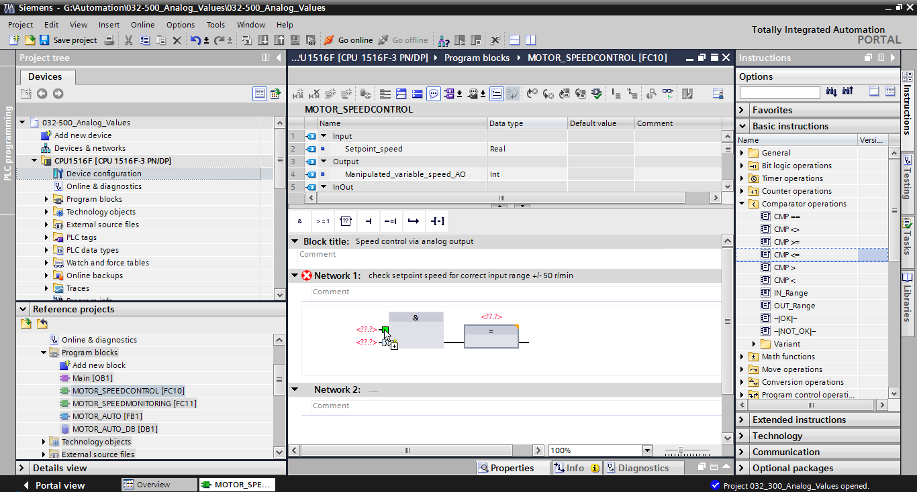

* Next use drag-and-drop to move the 'Comparator operation' 'Greater or equal' onto the second input of the  AND logic operation.   
  (→ Basic instructions → Comparator operations→ CMP>=)

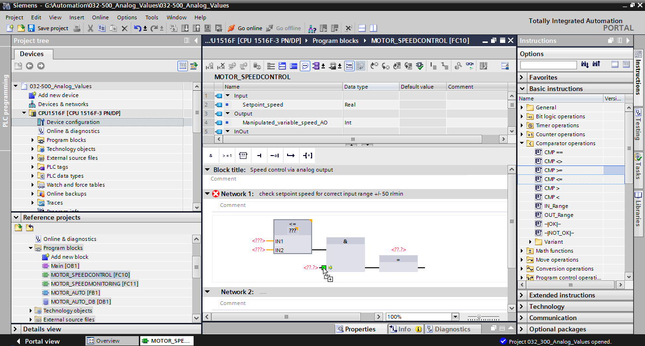

* Connect the contacts in Network 1 with the constants and local tags as shown here. The data types in the comparator operations are automatically adapted to 'Real'.

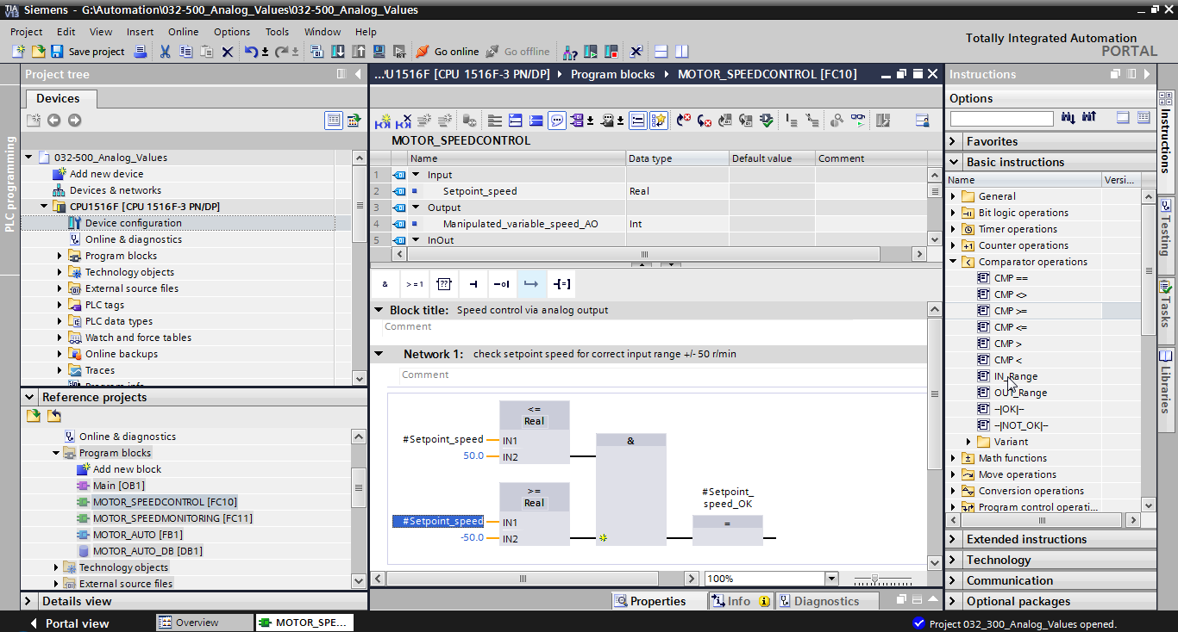

* Use drag-and-drop to move the 'Conversion operation' 'NORM\_X' into Network 2 in order to normalize the speed setpoint of +/- 50 rpm to +/- 1.   
  (→ Basic instructions → Conversion operations → NORM\_X)

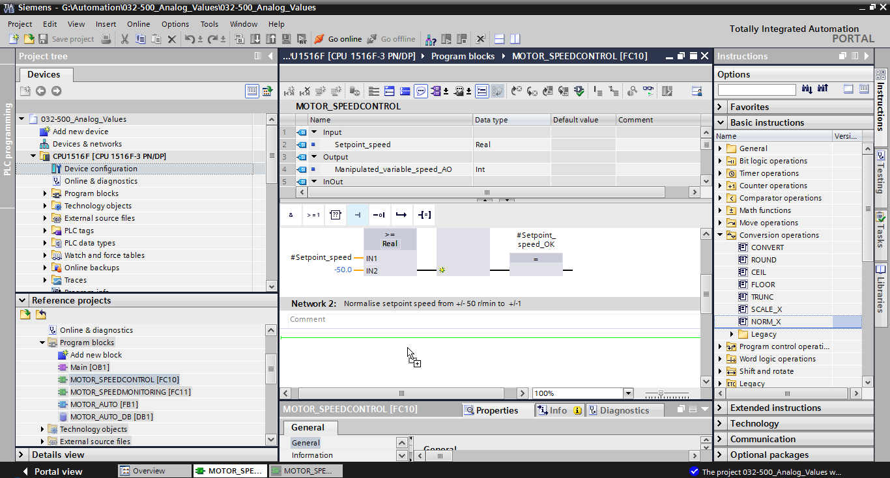

* Connect the contacts in Network 2 with the constants and local tags as shown here. The data types in 'NORM\_X' are automatically adapted to 'Real'.

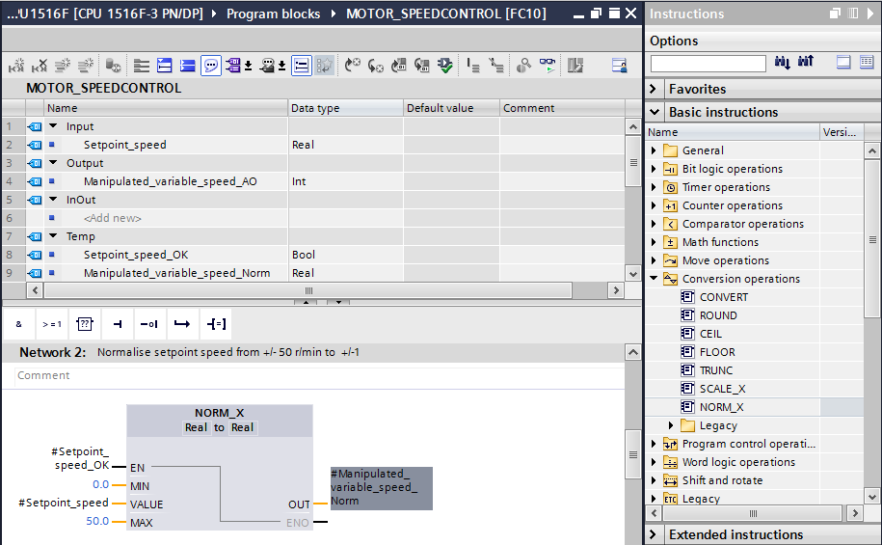

* Use drag-and-drop to move the 'Conversion operation' 'SCALE\_X' into Network 3 in order to scale the speed setpoint from the normalized +/- 1 onto the range for the analog output +/- 27468.   
  (→ Basic instructions → Conversion operations → SCALE\_X)

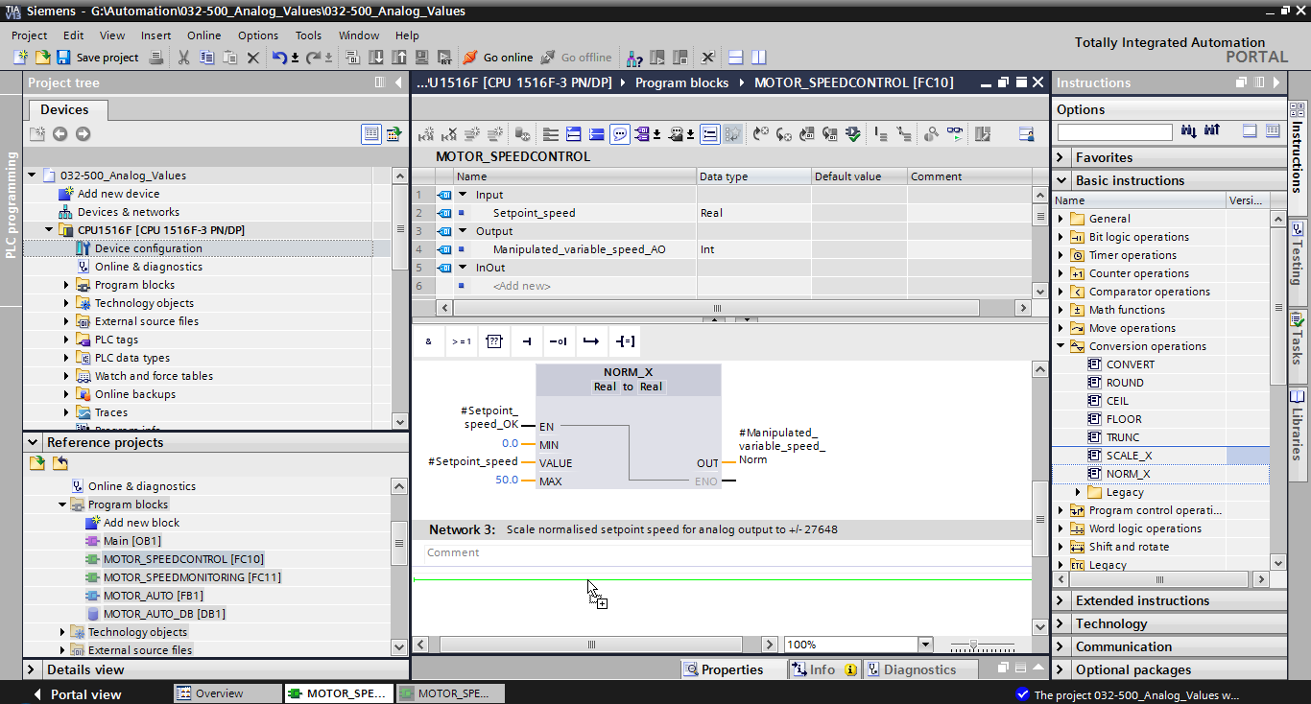

* Connect the contacts with the constants and local tags in Network 3 as well, as shown here. The data types in 'SCALE\_X' are automatically changed to 'Real' or 'Int'.

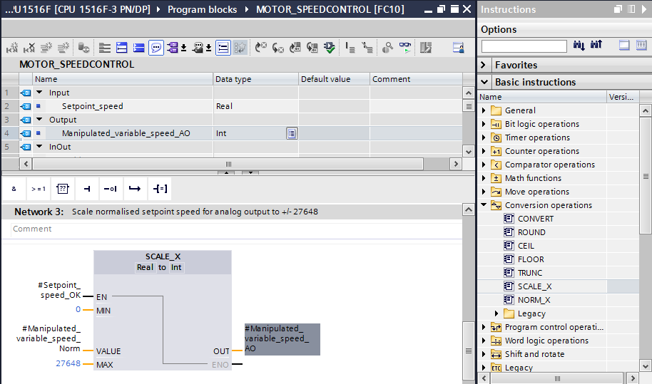

* Insert an Assignment '' in the fourth network. Use drag-and-drop to move the 'Move' command from the 'Move operations' folder under 'Basic instructions' in front of the Assignment.   
  (→  → Basic instructions → Move operations → MOVE)

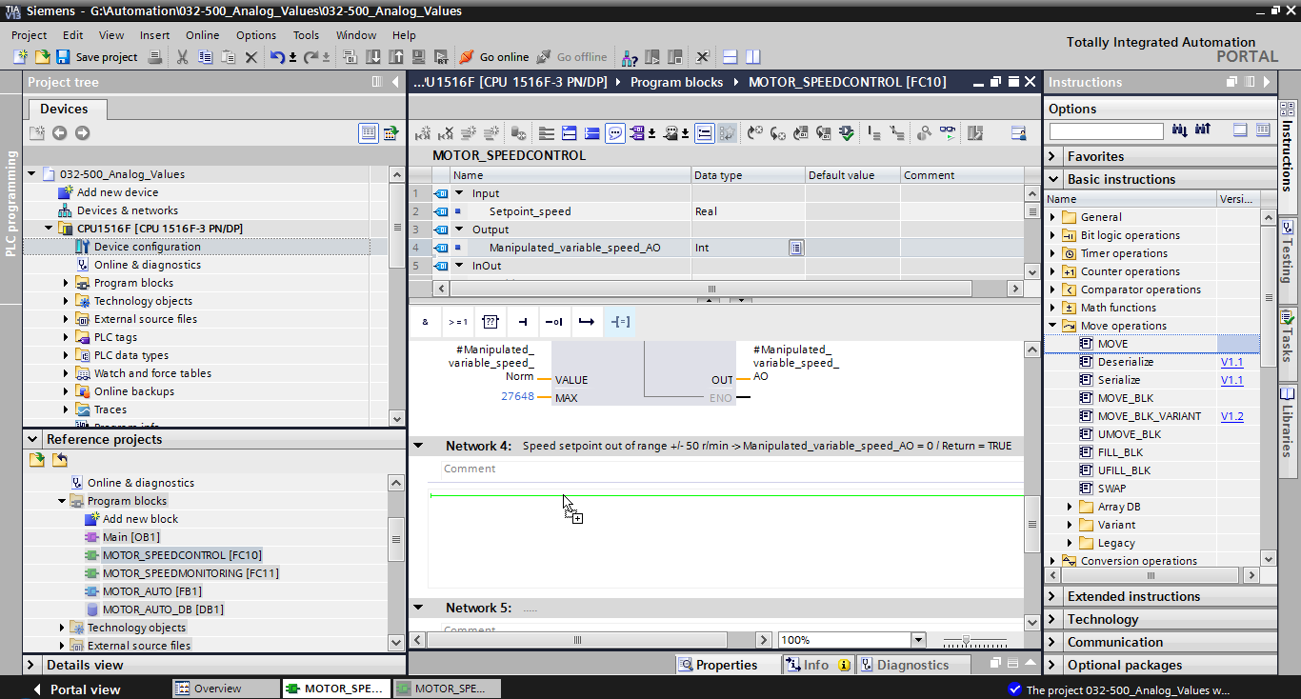

* The contacts in Network 4 will now be connected with constants and local tags as shown here. If the speed setpoint is not within the range +/- 50 rpm, the value '0' is output at the analog output and the value TRUE is assigned to the return value (Return) of the "MOTOR\_SPEEDCONTROL“ function.

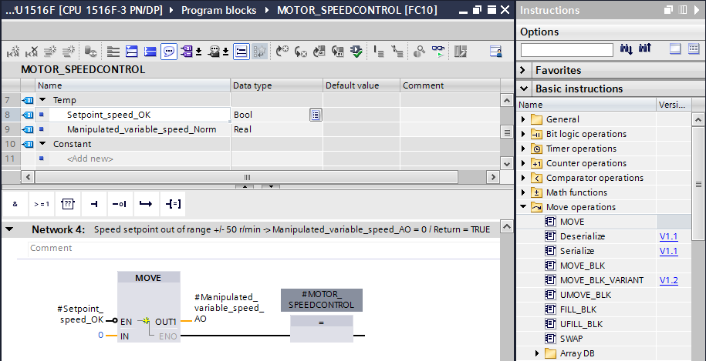

* Do not forget to click SaveButton_project. The finished function "MOTOR\_SPEEDCONTROL" [FC10] in FBD is shown below.

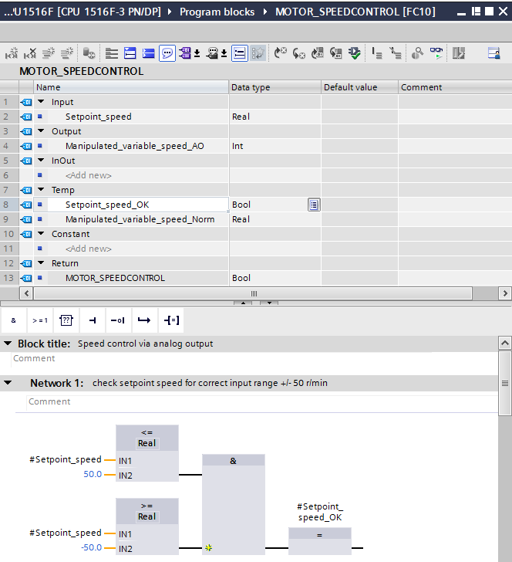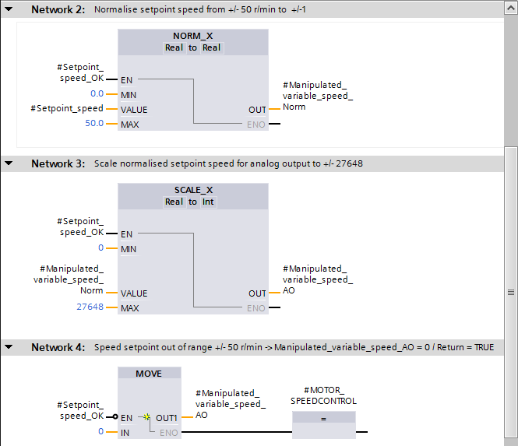

## Configuration of the analog output channel

* Double-click the 'Device configuration' to open it.

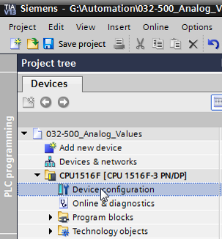

* Check the address setting and the configuration of the analog output channel 0.   
  (→ Q address: 64…71 → Properties → General → Output 0 - 3 → Outputs → Channel 0 → Output type: Voltage → Output range: +/- 10 V → Reaction to CPU STOP: Shutdown)

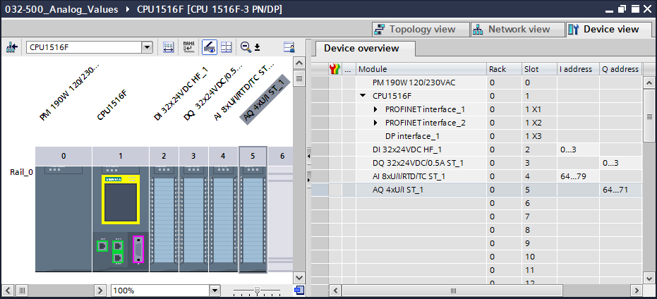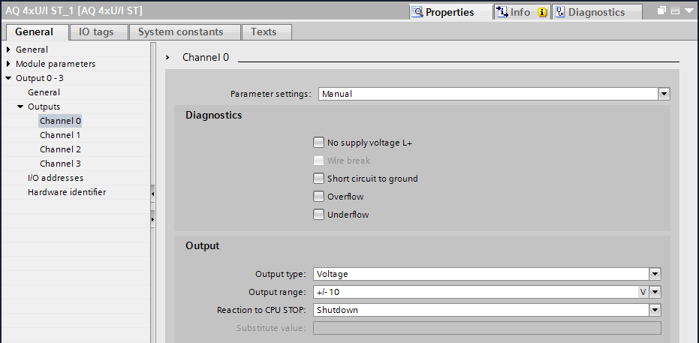

## Expand the tag table to include analog signals

* Double-click the 'Tag table\_sorting station' to open it.

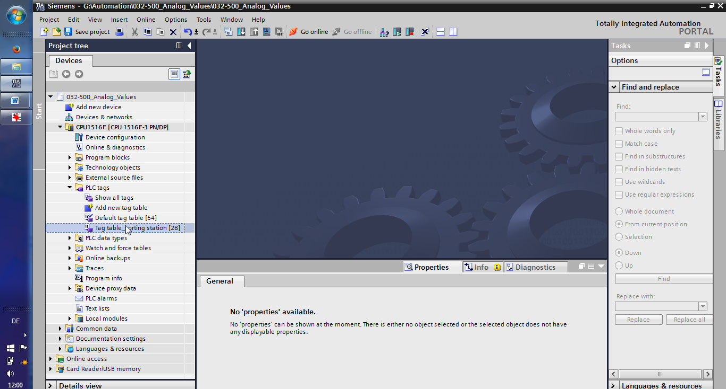

* Add the global tags for the analog value processing to the "Tag table\_sorting station". An analog input B8 and an analog output U1 must be added.   
  (→ U1 → %QW64 → B8 → %IW64)

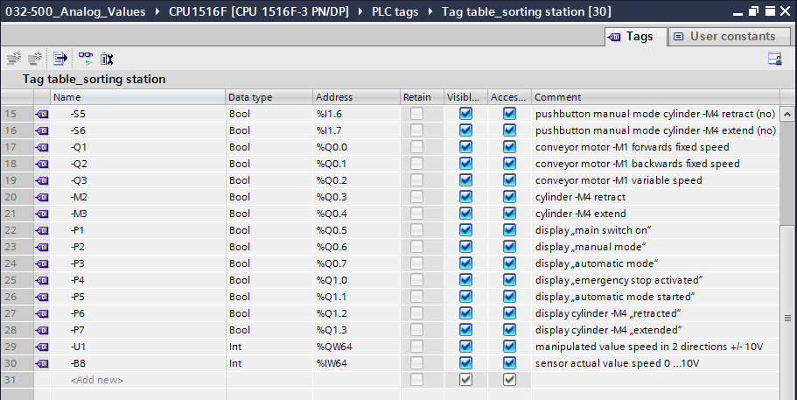

## Call the block in the organization block

* Open the "Main [OB1]" organization block with a double-click.

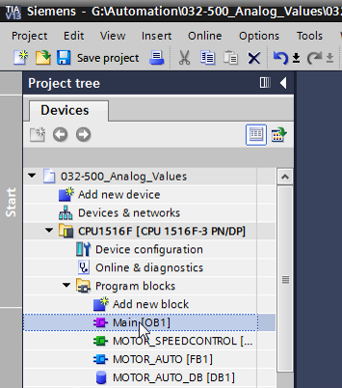

* Add the temporary tag 'Motor\_speed\_monitoring\_Ret\_Val' to the local tags of OB1. These will be needed in order to interconnect the return value of the "MOTOR\_SPEEDCONTROL" function.   
  (→ Temp → Motor\_speed\_monitoring\_Ret\_Val → Bool)

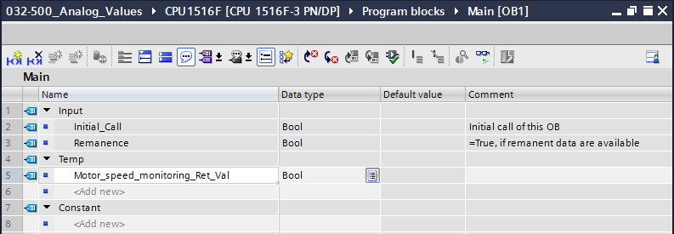

* Select the block title of OB1 and then click '' to insert a new Network 1 in front of the other networks   
  (→ )

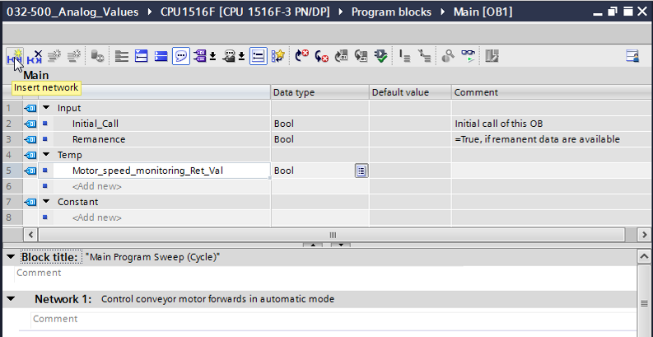

* Use drag-and-drop to move your "MOTOR\_SPEEDCONTROL [FC10]" function onto the green line in Network 1.

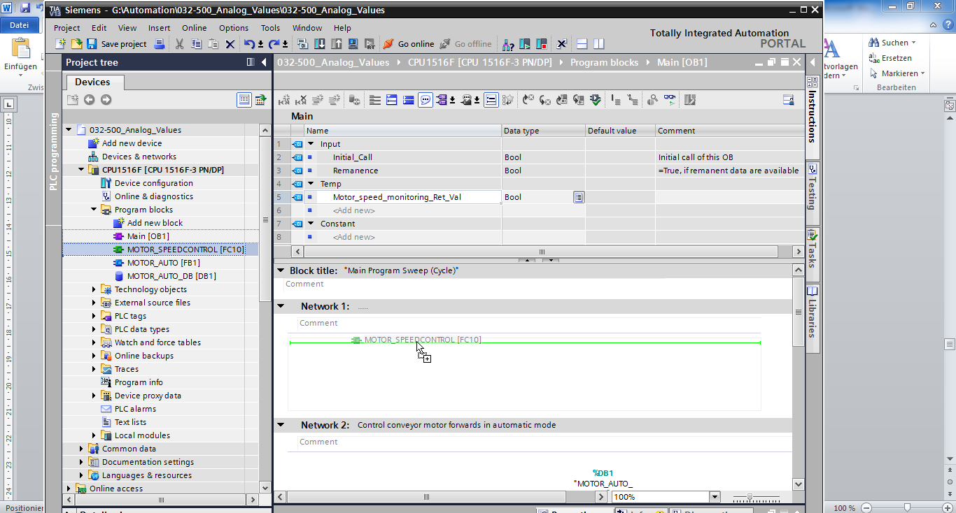

* Connect the contacts with the constants and global and local tags here as shown.

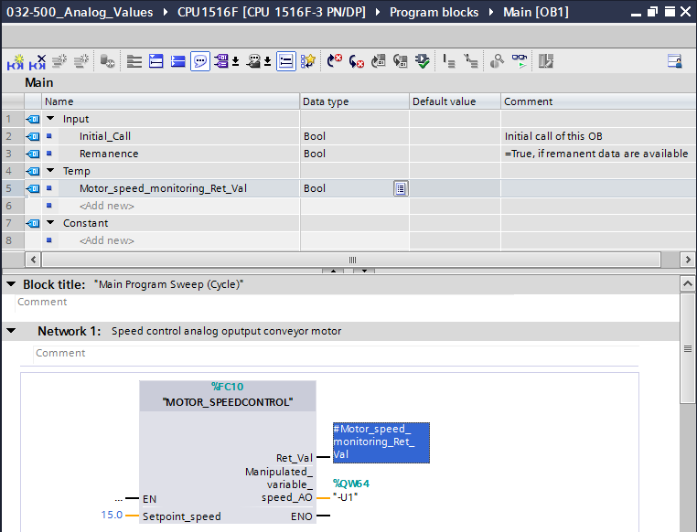

* Change the connection of output tag "Conveyor\_motor\_automatic\_mode" in Network 2 to '-Q3' (Conveyor motor -M1 variable speed) so that the conveyor motor is controlled taking the analog speed setting into consideration.   
  (→ -Q3)

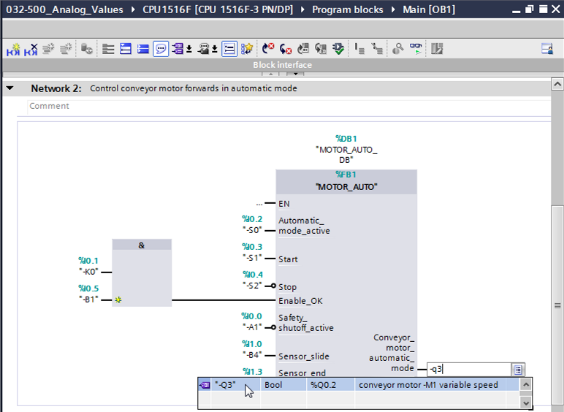

## Save and compile the program

* To save your project, select the SaveButton_project button in the menu. To compile all blocks, click the "Program blocks" folder and select the D:\00_DATA\SIEMENS\Unterlagen\08_Ausbildungsunterlage_TIA-Portal_R1502_dt\032-100 FC-Programmierung\pics\052.jpg icon for compiling in the menu.   
  (→ SaveButton_project → Program blocks → D:\00_DATA\SIEMENS\Unterlagen\08_Ausbildungsunterlage_TIA-Portal_R1502_dt\032-100 FC-Programmierung\pics\052.jpg)

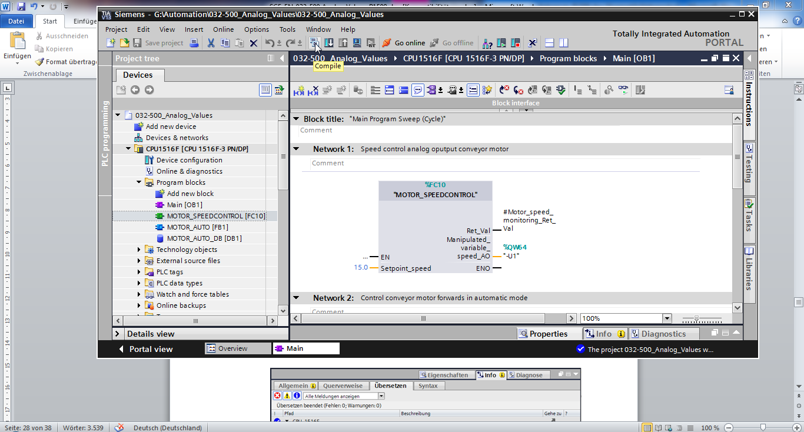

* The "Info", "Compile" area shows which blocks were successfully compiled.

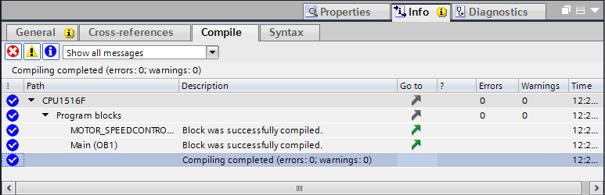

## Download the program

* After successful compilation, the complete controller with the created program including the hardware configuration can, as described in the previous modules, be downloaded. (→ )

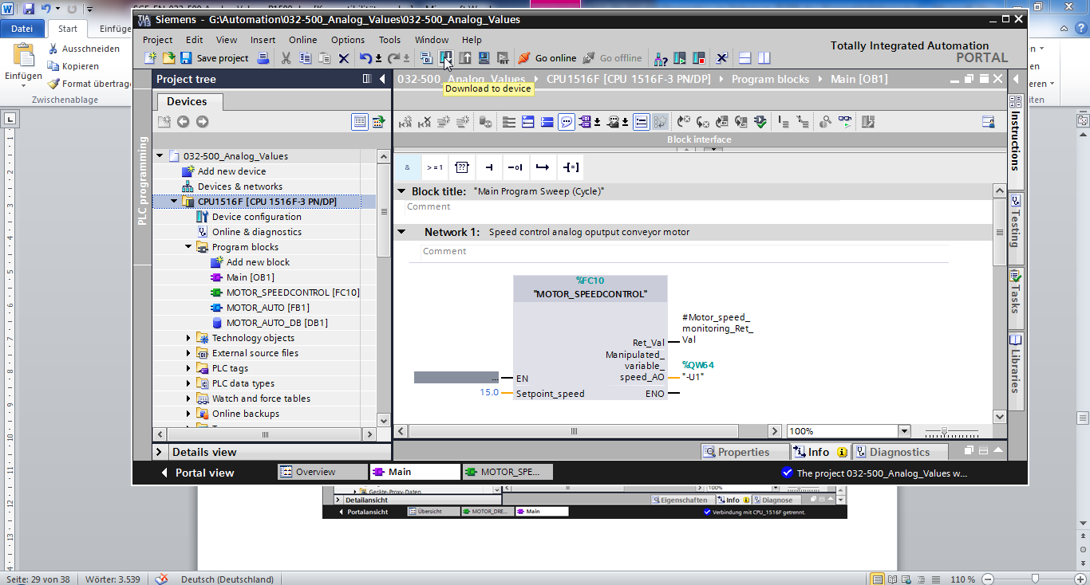

## Monitor program blocks

* The desired block must be open for monitoring the downloaded program. The monitoring can now be activated/deactivated by clicking the D:\00_DATA\SIEMENS\Unterlagen\08_Ausbildungsunterlage_TIA-Portal_R1502_dt\032-100 FC-Programmierung\pics\055b.jpg icon.   
  (→ Main [OB1] → D:\00_DATA\SIEMENS\Unterlagen\08_Ausbildungsunterlage_TIA-Portal_R1502_dt\032-100 FC-Programmierung\pics\055b.jpg)

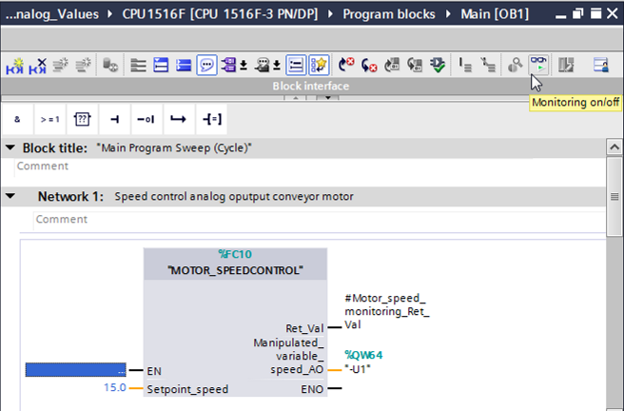

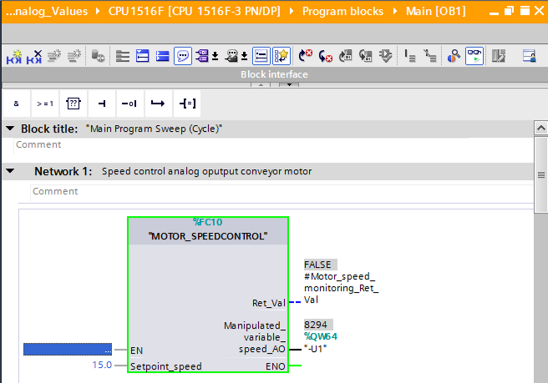

* The "MOTOR\_SPEEDCONTROL" [FC10] function called in the "Main [OB1]" organization block can be selected directly for "Open and monitor" after right-clicking and the program code in the function can thus be monitored.   
  (→ "MOTOR\_SPEEDCONTROL" [FC10] → Open and monitor)

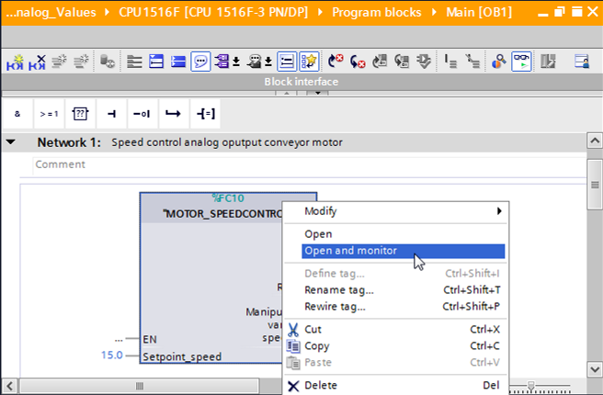

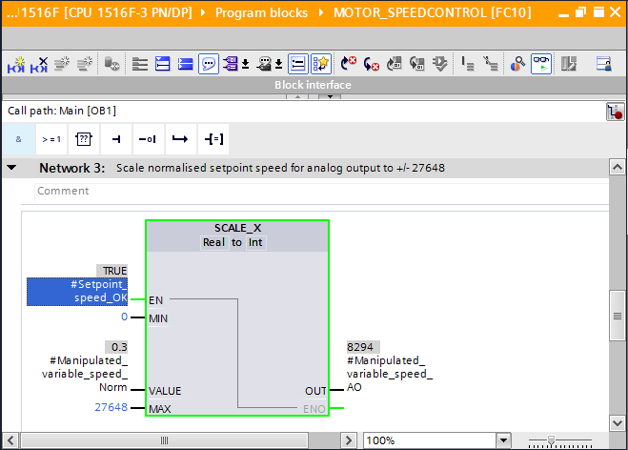

## Archive the project

* As the final step, we want to archive the complete project. Select the → 'Archive ...' command in the → 'Project' menu. Select a folder where you want to archive your project and save it with the file type "TIA Portal project archive".   
  (→ Project → Archive → TIA Portal project archive → 032-500\_Analog\_Values…. → Save)

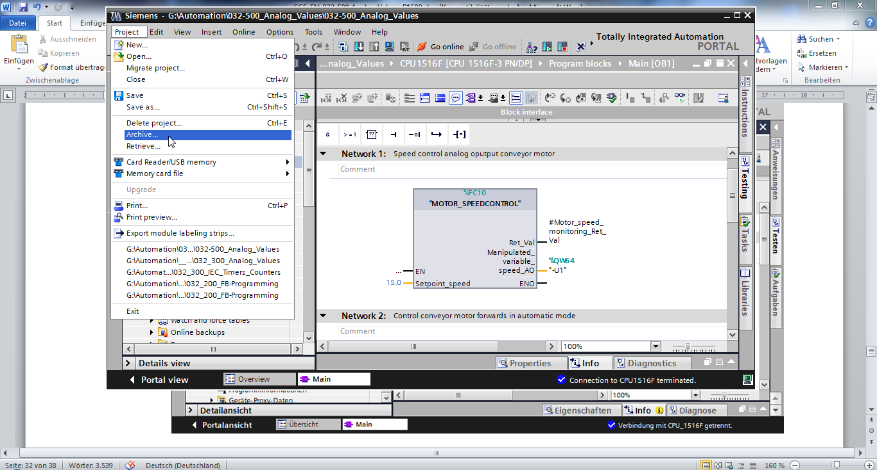

# Checklist

|  |  |  |
| --- | --- | --- |
| No. | Description | Completed |
| 1 | Compiling successful and without error message |  |
| 2 | Download successful and without error message |  |
| 3 | Switch on station (-K0 = 1)  Cylinder retracted / Feedback activated (-B1 = 1)  EMERGENCY OFF (-A1 = 1) not activated  AUTOMATIC mode (-S0 = 1)  Pushbutton automatic stop not actuated (-S2 = 1)  Briefly press the automatic start pushbutton (-S1 = 1)  Sensor part at slide activated (-B4 = 1)  then Conveyor motor M1 variable speed (-Q3 = 1)  switches on and stays on.  The speed corresponds to the speed setpoint in the range +/- 50 rpm |  |
| 4 | Sensor part at end of conveyor activated (-B7 = 1) → -Q3 = 0 (after 2 seconds) |  |
| 5 | Briefly press the automatic stop pushbutton (-S2 = 0) → -Q3 = 0 |  |
| 6 | Activate EMERGENCY OFF (-A1 = 0) → -Q3 = 0 |  |
| 7 | Manual mode (-S0 = 0) → -Q3 = 0 |  |
| 8 | Switch off station (-K0 = 0) → -Q3 = 0 |  |
| 9 | Cylinder not retracted (-B1 = 0) → -Q3 = 0 |  |
| 10 | Project successfully archived |  |

# Exercise

## Task – Exercise

In this exercise a "MOTOR\_SPEEDMONITORING" [FC11] function will be created additionally.

The actual value will be made available to -B8 (sensor actual value speed of the motor +/-10V corresponds to +/- 50 rpm) as an analog value and queried at an input of the "MOTOR\_SPEEDMONITORING" [FC11] function. The data type is 16-bit integer (Int.).

This actual speed value will first be normalized to the range +/- 1 as 32-bit floating-point number (Real) in the function.

The normalized actual speed value will then be scaled to revolutions per minute (range: +/- 50 rpm) as 32-bit floating-point number (Real) and made available at an output.

The following 4 limit values can be specified as 32-bit floating-point numbers (Real) at the block inputs in order to monitor them in the function:

Speed > Motor\_speed\_monitoring\_error\_max

Speed > Motor\_speed\_monitoring\_warning\_max

Speed < Motor\_speed\_monitoring\_warning\_min

Speed < Motor\_speed\_monitoring\_error\_min

If a limit value is exceeded or fallen below, the value TRUE (1) is assigned to the corresponding output bit.

If a fault is present, the protective tripping of the "MOTOR\_AUTO" [FB1] function block will be tripped.

## Technology diagram

Here you see the technology diagram for the task.



Figure 3: Technology diagram



Figure 4: Control panel

## Reference list

The following signals are required as global operands for this task.

|  |  |  |  |  |
| --- | --- | --- | --- | --- |
| **DI** | **Type** | **Identifier** | **Function** | **NC/NO** |
| I 0.0 | BOOL | -A1 | Return signal emergency stop OK | NC |
| I 0.1 | BOOL | -K0 | Main switch "ON" | NO |
| I 0.2 | BOOL | -S0 | Mode selector manual (0)/ automatic (1) | Manual = 0  Auto = 1 |
| I 0.3 | BOOL | -S1 | Pushbutton automatic start | NO |
| I 0.4 | BOOL | -S2 | Pushbutton automatic stop | NC |
| I 0.5 | BOOL | -B1 | Sensor cylinder -M4 retracted | NO |
| I 1.0 | BOOL | -B4 | Sensor part at slide | NO |
| I 1.3 | BOOL | -B7 | Sensor part at end of conveyor | NO |
| IW64 | BOOL | -B8 | Sensor actual value speed of the motor +/-10V corresponds to +/- 50 rpm |  |

|  |  |  |  |  |
| --- | --- | --- | --- | --- |
| **DO** | **Type** | **Identifier** | **Function** |  |
| Q 0.2 | BOOL | -Q3 | Conveyor motor -M1 variable speed |  |
| QW 64 | BOOL | -U1 | Manipulated value speed of the motor in 2 directions +/- 10V corresponds to +/- 50 rpm |  |

***Legend for reference list***

|  |  |
| --- | --- |
| DO | Digital Output |
| AO | Analog Output |
| Q | Output |

|  |  |
| --- | --- |
| DI | Digital Input |
| AI | Analog Input |
| I | Input |
| NC | Normally Closed |
| NO | Normally Open |

## Planning

Plan the implementation of the task on your own.

## Checklist – Exercise

|  |  |  |
| --- | --- | --- |
| No. | Description | Completed |
| 1 | Compiling successful and without error message |  |
| 2 | Download successful and without error message |  |
| 3 | Switch on station (-K0 = 1)  Cylinder retracted / Feedback activated (-B1 = 1)  EMERGENCY OFF (-A1 = 1) not activated  AUTOMATIC mode (-S0 = 1)  Pushbutton automatic stop not actuated (-S2 = 1)  Briefly press the automatic start pushbutton (-S1 = 1)  Sensor part at slide activated (-B4 = 1)  then Conveyor motor -M1 variable speed (-Q3 = 1)  switches on and stays on.  The speed corresponds to the speed setpoint in the range +/- 50 rpm |  |
| 4 | Sensor part at end of conveyor activated (-B7 = 1) → -Q3 = 0 (after 2 seconds) |  |
| 5 | Briefly press the automatic stop pushbutton (-S2 = 0) → -Q3 = 0 |  |
| 6 | Activate EMERGENCY OFF (-A1 = 0) → -Q3 = 0 |  |
| 7 | Manual mode (-S0 = 0) → -Q3 = 0 |  |
| 8 | Switch off station (-K0 = 0) → -Q3 = 0 |  |
| 9 | Cylinder not retracted (-B1 = 0) → -Q3 = 0 |  |
| 10 | Speed > Motor\_speed\_monitoring\_error\_max → -Q3 = 0 |  |
| 11 | Speed < Motor\_speed\_monitoring\_error\_min → -Q3 = 0 |  |
| 12 | Project successfully archived |  |

# Additional information

You can find additional information as an orientation aid for initial and advanced training, for example: Getting Started, videos, tutorials, apps, manuals, programming guidelines and trial software/firmware, at the following link:   
  
[www.siemens.com/sce/s7-1500](http://www.siemens.com/sce/s7-1500)